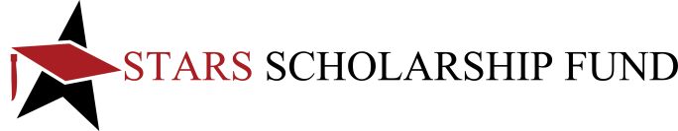 | MEDIA SPONSORSHIP AGREEMENT  PRINT/OUTDOOR/WEB MEDIA  LAREDO
SPONSORSHIP LEVEL Please select one

 | CROWN OF JEWELS  ($35,000) |  | DOUBLE DIAMOND  ($30,000) |  |  | DIAMOND  ($20,000) |  |  | EMERALD  ($15,000)
SPONSORSHIP AMOUNT: |  | $ |  |  |  | TYPE OF MEDIA: |  |  | OUTDOOR |  |  | PRINT |  | WEB
SPONSOR INFORMATION
NAME OF COMPANY/ORGANIZATION:
NAME AS IT SHOULD APPEAR IN STARS PROMOTIONS:
“Crown of Jewels” and “Double Diamond” sponsors should send one logo to laura.escamilla@starsscholarship.org
I will email logo Please use logo on file I do not have a logo, please print name as listed above
CONTACT PERSON: |  |  |  |  |  |  |  | TITLE:
PHYSICAL ADDRESS:
(Donor gifts will be delivered to this address, no P.O. Boxes)
CITY: |  |  |  | STATE: |  |  |  |  |  | ZIP:
PHONE: |  |  |  | EMAIL:
COMPANY FACEBOOK:  facebook.com/ |  |  |  | COMPANY INSTAGRAM HANDLE:  @ |  |  |  |  |  | COMPANY TWITTER HANDLE:  @

LIST OF PUBLICATIONS/SITES INCLUDED IN THIS AGREEMENT:
 | PULBICATION NAME | LANUAGE | VALUE | PROOF OF PERFORMANCE SHOULD BE SENT TO  NATALIE VIDALES  MARKETING MANAGER  L&F DISTRIBUTORS  6949 MARKET  EL PASO, TX 79915  EMAILED TO  media@lnfdist.com
1. |  | ENGLISH SPANISH | $
2. |  | ENGLISH SPANISH | $
3. |  | ENGLISH SPANISH | $
4. |  | ENGLISH SPANISH | $
5. |  | ENGLISH SPANISH | $
 | OUTDOOR ADVERTISING |  | $

I understand that all dollars will be utilized under mutually agreed upon date and terms.

I understand that any specific instructions must be provided to Stars Scholarship Fund in a proposal format.

This agreement has been authorized on ______/_______/2021
By: Print Name Here | Title: | Signature

SPONSORSHIP FORMS MAY BE
 EMAILED TO Natalie.vidales@lnfdist.com
 EMAILED TO Laura.Escamilla@starsscholarship.org

